Evaluating 2020 Age-Grade Standards Against 2019 Rankings

# Alan Jones and Tom Bernhard

# 2020-06-20

## Location of tables

The tables are in a public repository on GitHub.

<https://github.com/AlanLyttonJones/Age-Grade-Tables>

## Introduction

Alan Jones has produced the road-running age-grade standards every five years since 2005. These standards were based on single-age bests at each distance as compiled by Ken Young who created the Association of Road Racing Statisticians (ARRS): <http://arrs.run>. Unfortunately, Ken died in 2018. The data used for the 2020 age-grade standards are comprised of Ken’s most recent data along with significant new Masters data supplied by Tom Bernhard.

Using these revised data, Alan created new, standards for 2020. To evaluate them, Tom used the 2019 Masters age-graded rankings to compare the 2020 proposed standards against the 2015 standards. That is, he computed each runner’s performance factor which is a percentage of how close that runner is to running the age standard for the runner’s age and gender. In this document, the rankings for the distances 1 Mile, 5 km, 10 km, Half Marathon, and Marathon are given in a table. These are the same distances that Alan uses in determining the factors since more races are held at these distances. He interpolates to determine the standards at the other distances. After each of Tom’s tables, a graph showing the 2015 and 2020 factors vs age are displayed along with an explanation of the differences observed in each table.

The data for the road mile are quite sparse. The Road Mile age-grade standards were created using the 5 km age-factors and the Mile Open Class (OC) times for both men and women.

## Approval by LDR of the USATF

On May 20, 2020, these standards were approved by the Long Distance Running Council of USAT Track and Field.

## 1 Mile Men

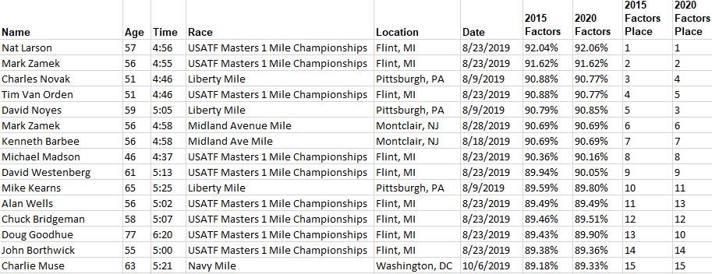

The changes are rather small. There was no change for a 56-year-old runner. Ages less than 56 were slightly hurt while those above 56 were slightly helped by the new standards.

## 1 Mile Women

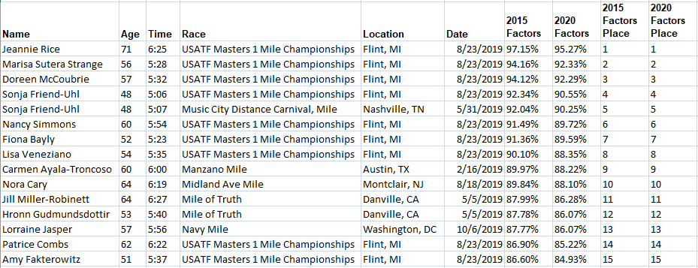

Women of all ages were slightly hurt by the 2020 standards but there were not enough changes across the age range to change the order of finish.

## 5 km Men

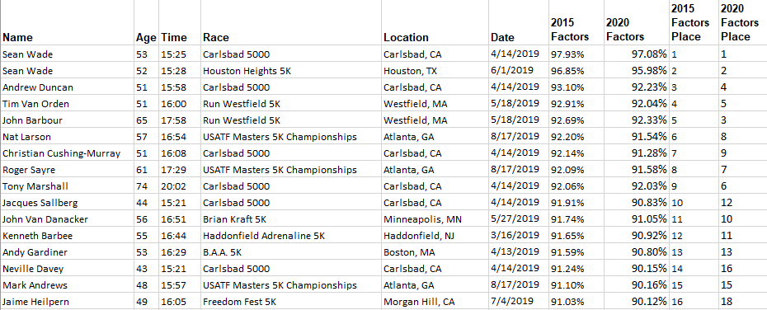

Notice that men of all ages were hurt by the new factors but the younger ones more than the older men.

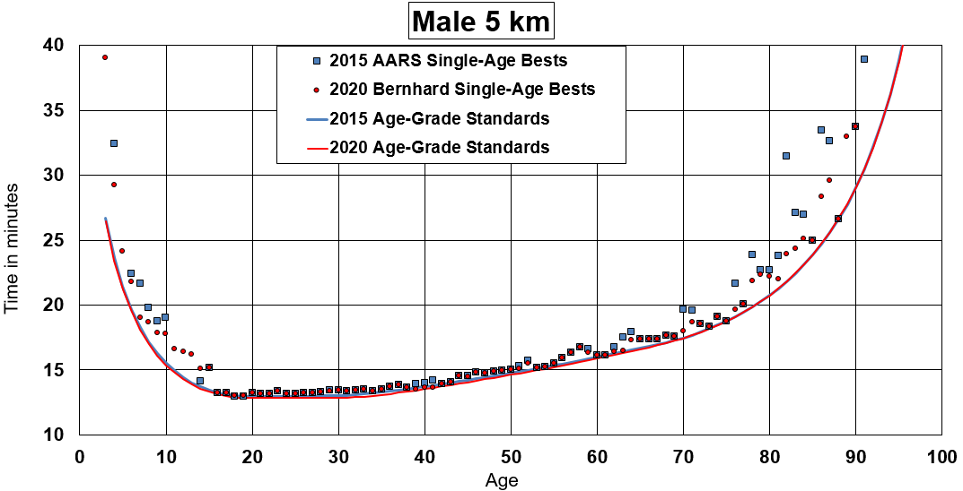Ages 30-60 are hurt because the OC changed by 1% and there was a new improved record at age 41. Ages 65 and above did not change much because there were no new single-age bests.

## 5 km Women

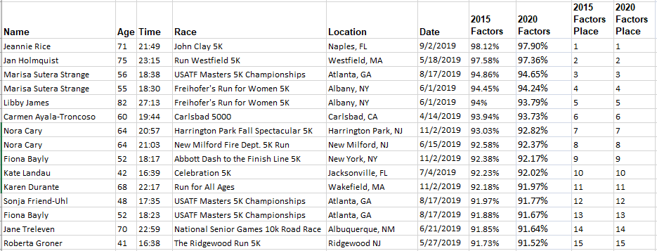

There is no change in the rankings because the changes are similar over the entire age range.

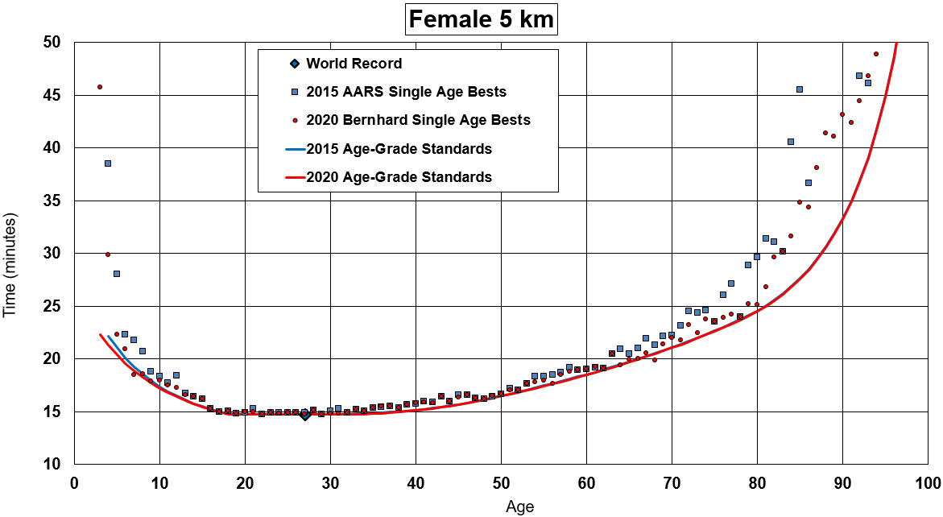

Note how the 2015 and 2020 lines almost fall on top of each other for ages above 15. The age 68 best is an outlier.

## Men 10 km

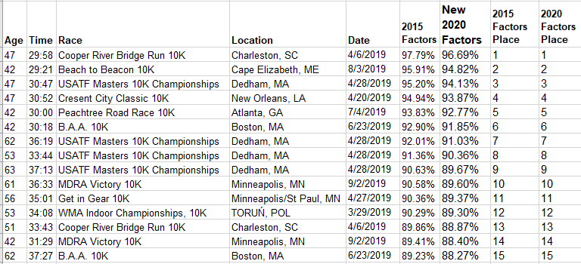

The places don’t change. 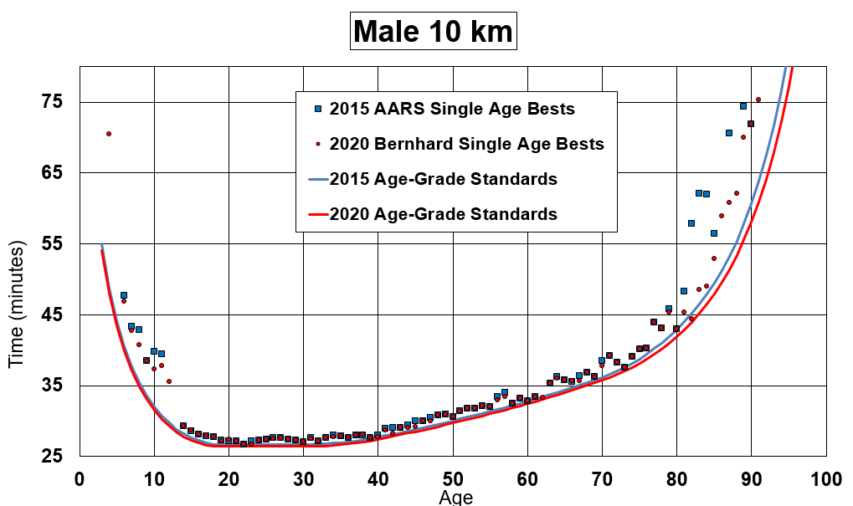

The factors are close up through age 70. Above 70 the standards get tougher due to a new record at age 82

## Women 10 km

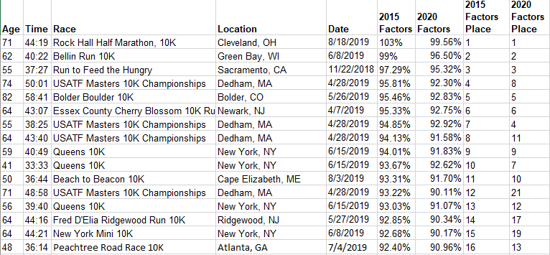

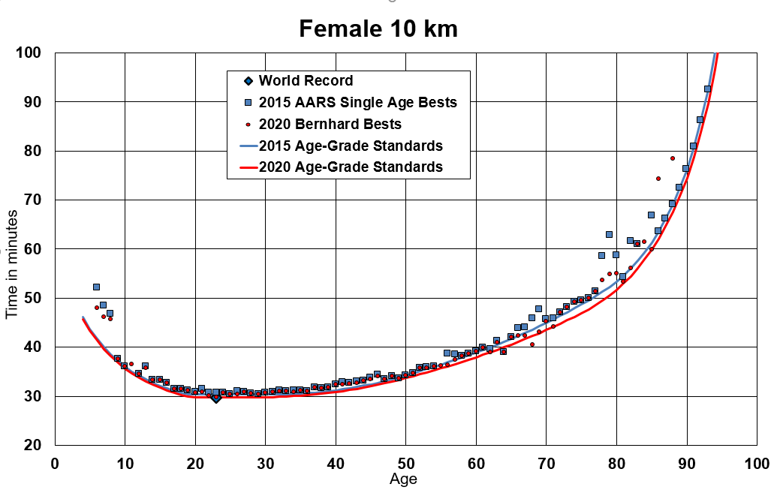

The women from ages 55 through 85 are hurt by the new standards due to new records at ages 69, 71, 81, and 85. The times at ages 64 and 68 are deemed outliers.

## Men Half Marathon

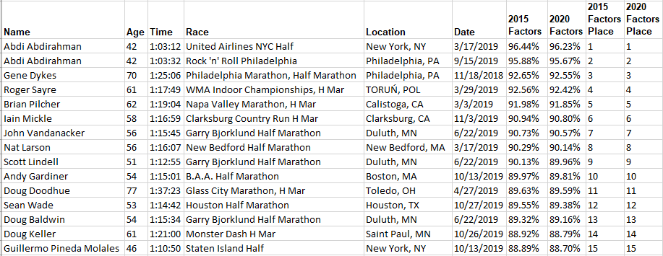

The changes are small resulting in unchanged places.

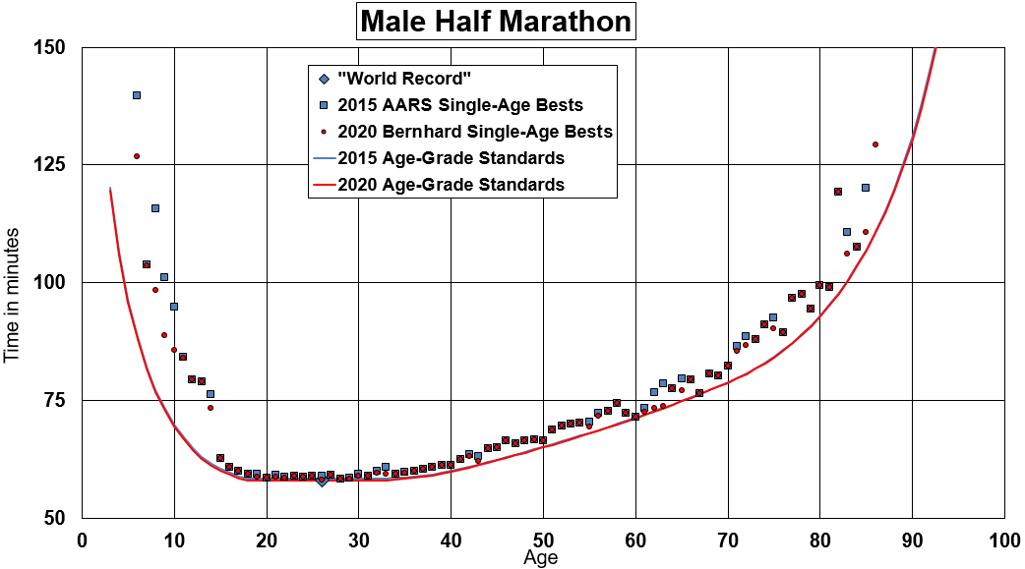

The two lines lie just about on top of each other. The OC improved by 0.63% which is roughly the change for the ages 5 to 32. The change is even smaller from ages 33 to 83.

## Women Half Marathon

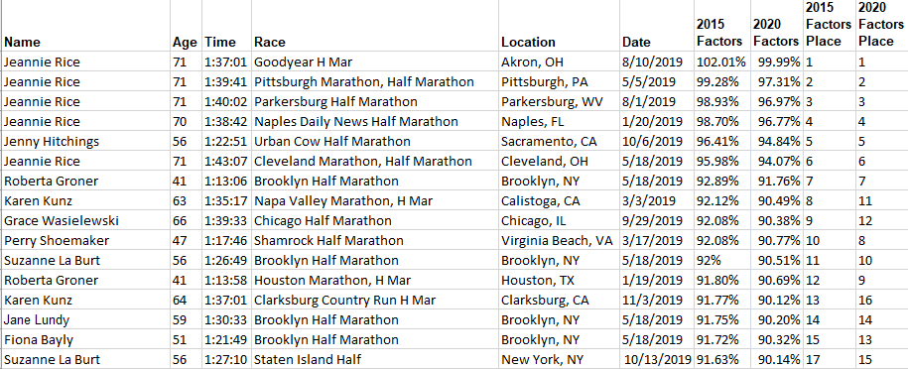

There are several changes. Runners in their 60s are hurt by the new standards and those in the 40s and 50s are hurt also but not by as much, resulting in their places moving up. The graph helps to explain why.

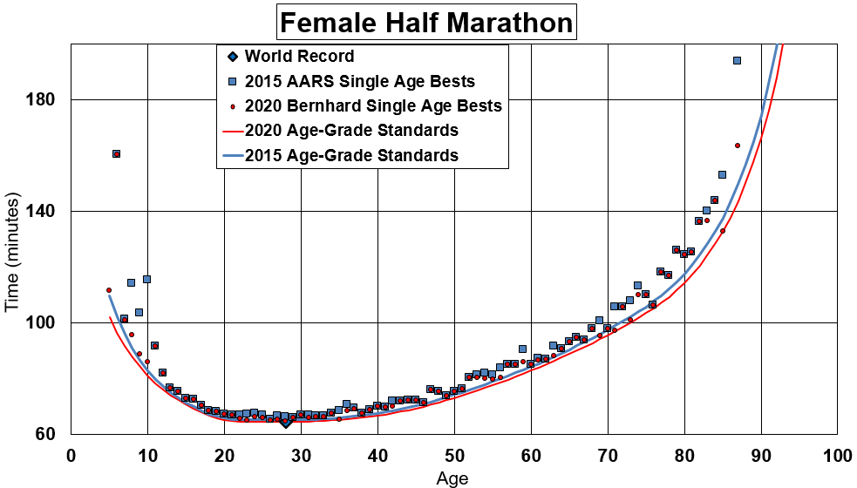

The OC has changed by 1.05%. That is the change for those in their 20s. The ages from 40 up are hurt more because of new records for ages 71 and 85.

## Men Marathon

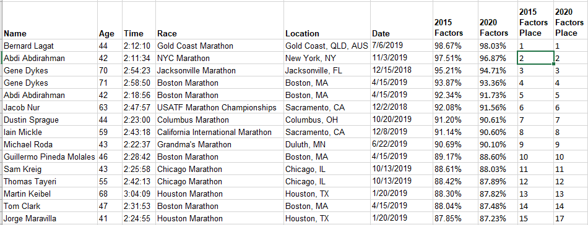

The only place change is in 15th place where that runner dropped to 17th place. This implies that the changes are rather uniform across the ages. The graph shows this. 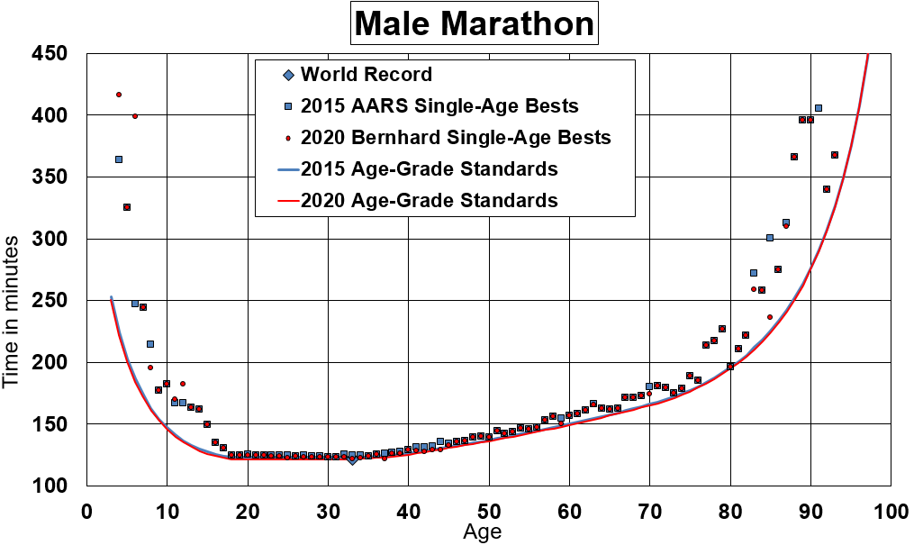

The OC changed by 1.06%. That is roughly the change from the youngest ages through age 32. Starting at age 32 the change is even less.

## Women Marathon

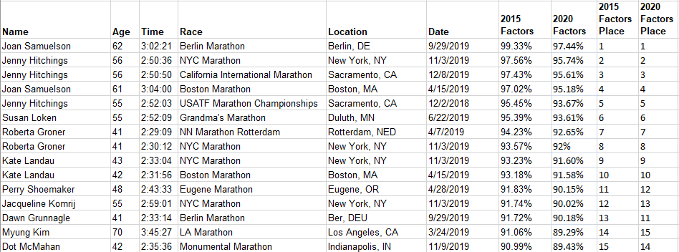

The only change in the last place where, using the 2015 factors, 70-year-old Myung Kim beats 42-year-old Dot McMahan but their places are reversed using the 2020 factors.

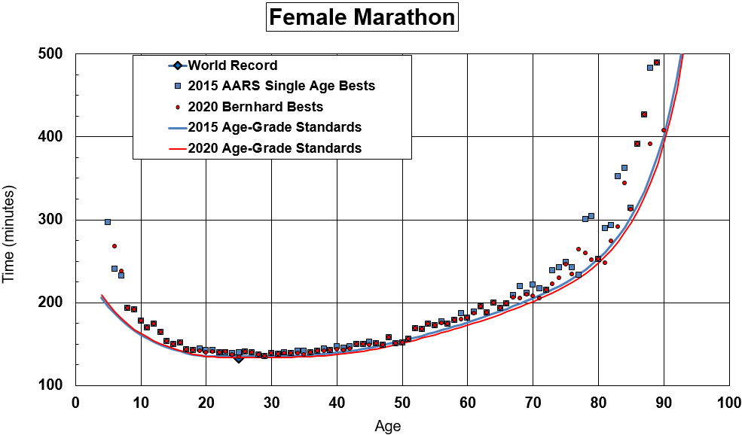

You can see that the gap between the 2015 and 2020 lines is larger for a 70-year-old than for a 42-year old giving the 70-year-old a slight disadvantage over her 42-year-old competitor. That is why Myung Kim moved from 14th place using the 2015 standards to 15th place using the 2020 standards.

# Summary

As has happened in the past when considering new standards, the changes in the female standards are greater than on the male side. However, it would result in much confusion if we were to release new female standards and keep the male standards the same. After all, there ARE changes in the male standards, and they should be recognized.